Adam Guo

2/9/2018

Method Paper for Dementia Patient Research

**Sample**

The population of interest of this research study is ideally dementia patients, who have trouble remembering their daily activities. However, due to the physical limitations, the population that is available to this study has been mostly college students, whose motions are for the most part identical to that of dementia patients. Currently, the participants of the research study are all in the age range of 19-22, are fully healthy and have unimpaired motor functions.

**Measure/Devices**

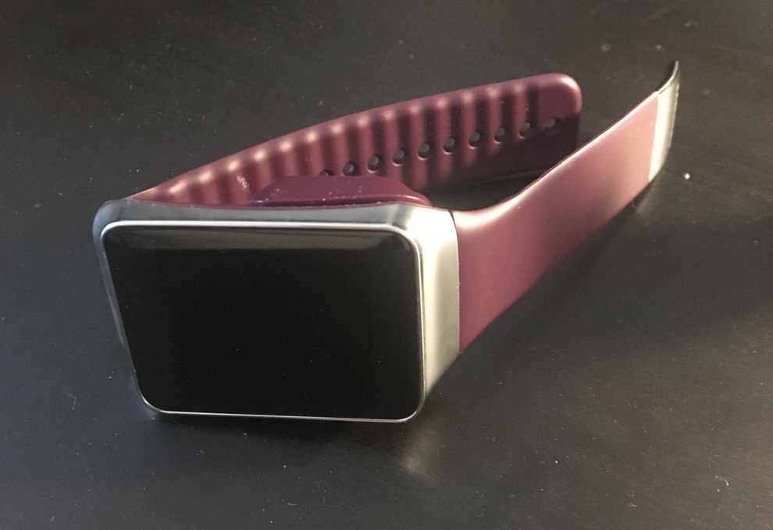Measurement of the study is done by using Samsung’s first generation smartwatch, which comes equipped with Wifi and Bluetooth, as well as sensors such as accelerometer, gyroscope, and GPS location tracking. The data collection of the smartwatch is accomplished by an Android application called “Wada” developed by graduate students in the Computer Science department under Professor Stankovic. After launching the application, users of the smartwatch will have to press the “start” button to start the data collection of the smartwatch. The application will record the readings of the x, y, z coordinates of the accelerometer in a few milliseconds interval, as well as the readings of the gyroscope. When the “stop” button is pressed, the program will end its data collection and automatically save the file in the smartwatch’s memory.

**Data Processing**

Extracting the data from the smartwatch will require connecting the watch to a computer via cable or Wifi, and using Android’s ADB debugging to copy the files from the program folder to your local machine. The raw data consists of eight untitled columns, with the first one being the raw timestamp, the second being the sensor type (numbered 1-11), the fourth through sixth being the accelerometer and gyroscope data of the x, y, and z coordinates, and the other column are irrelevant to the scope of this study. The data preparation usually includes appending a column titled the “seconds” and filling the column by calculating the actual seconds elapsed of the data from the start. The reason for this operation is to better compare the data with the video recording and to better label the micro-activities.

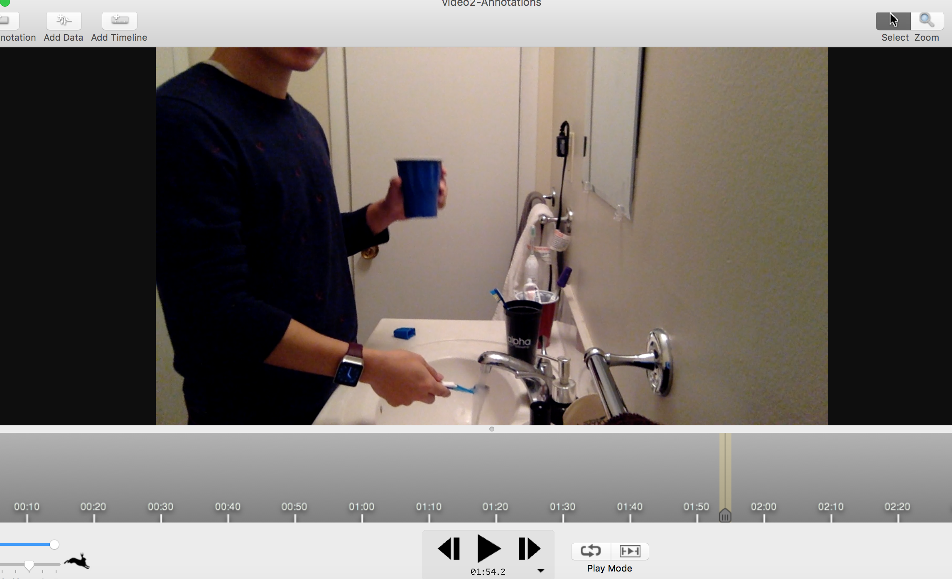The data labeling is achieved by using a software called Chronoviz, which allows user to lay your data side by side with the video recording. Currently every action performed by the participants is video recorded, to allow for manual data labeling. In the example of brushing, the entire brushing activities include micro-activities such as turning on the water, putting on tooth paste, the brushing motion, rinsing, etc. And only by labeling and separating them can we best build classifiers on the tooth brushing activities. Chronoviz allows you to export an annotations file, and once that is obtained, some further processing needs to be done before we can run the dataset through Weka, a machine learning software that helps you choose data models.

To obtain features from the dataset in order to build models, we need to perform some calculations based on the existing data. As a start, I obtained the mean, standard deviation, and min/max values of each of x, y, and z coordinates. I also used a one-second window for each feature, meaning I averaged the values of standard deviation of x from 0s to 1s, 1s to 2s, and so on. That will give you twelve columns of different features, in one-second window (can change to 0.5s or 2.0s). Using the annotations we got earlier from Chronoviz, we can add another column of feature titled “Activity,” which will specify which micro-activities is happening in that time window. This is what the resulting features look like:

